

**Talend Workshop**

**Documentation**

**Title: Context and Global Variables**

**Submitted By**

**Grimita Sanjay Purusharthi BDSA01**

**Vaibhavi Sangawar BDSA02**

**Upasana Mehta BDSA13**

**Shweta Sadwani BDSA22**

**DEPARTMENT OF COMPUTER ENGINEERING**

MIT ACADEMY OF ENGINEERING

ALANDI (D), PUNE

**Index**

|  |  |  |
| --- | --- | --- |
| Sr.No | Topic | Page Number |
| 1. | Prerequisites | 3 |
| 2. | Context Variables | 5 |
| 3. | Creating Context Variable Group | 5 |
| 4. | How to apply context variables to a Job | 10 |
| 5. | Context Values dynamically from a flow or File or Database / Load Context Values from a file | 15 |
| 6. | Using implicit context loading to load contexts / Setup Implicit Context File Location / Load a Context Value from a Properties File | 21 |
| 7. | How to Use Studio global variables / How to Create User defined global variables / Using tSetGlobalVar to create Global Variable / Create a Context and Create a globalMap Value Using tJava | 23 |
| 8. | Create a User Defined Global Variable and Pass it as a parameter / Create a User Defined Global Variable and Use it / Use and Print any Global Variable to Console | 25 |

**Prerequisites**

The exercises that need to be done for context variable require MySQL Connection.

For MySQL Connection:

1. Install XAMPP on your PC. Refer link below to download it.

<https://www.apachefriends.org/download.html>

2. Once Installation is done. Open the application and click start on Apache and MySQL button.

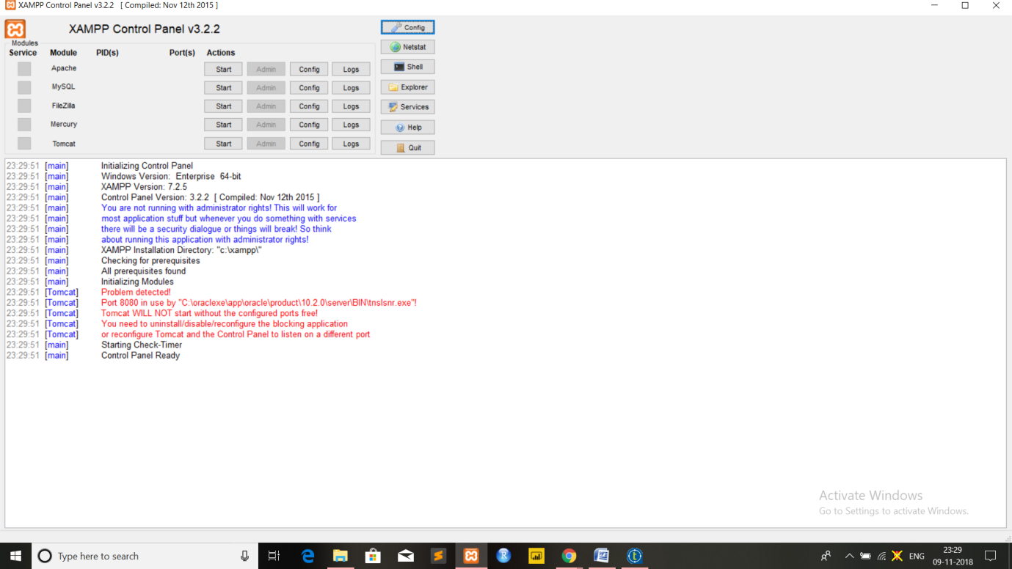

But at first you have to set/change the MySQL Root password. Type localhost or 127.0.0.1 in your browser's address bar. If you haven't deleted anything from the htdocs folder the xampp status page appears. Navigate to security settings and change your mysql root password.

Now, you can browse to your phpmyadmin under <http://localhost/phpmyadmin/>

Use the link (<https://complete-concrete-concise.com/web-tools/creating-a-mysql-database-using-xampp/> ) to refer how to create database in MySQL.

Once all steps are followed please note the information given below as it will be needed in the exercises.

host – localhost

port – 3306

database – name of database you want to refer (here railway will be used as database)

username – root

password – your password (if you have changed)

Please insure that your password is correct, sometime password is blank too, if nothing is working change your password and validate in config.inc.php file in phpmyadmin folder in xampp folderby defining your password in section (here blank)as shown in fig below:

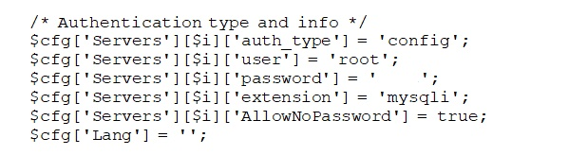

table_name : table you want to use which must be present in your database (here customer will be used as table_name).

Before proceeding please make sure this steps are followed.

**1. Context Variables**

Variables can change its value throughout execution of any program. A context variable is a variable which is defined by the user for a particular context. For example, depending upon the situation there can be different contexts like production or test. There can be different stages involved in testing before a particular Job goes for production, so different context variable can be used in such situations.

**2. Creating Context Variable Group**

Steps:

1. Right click Context node in Repository and select create context variable from it.

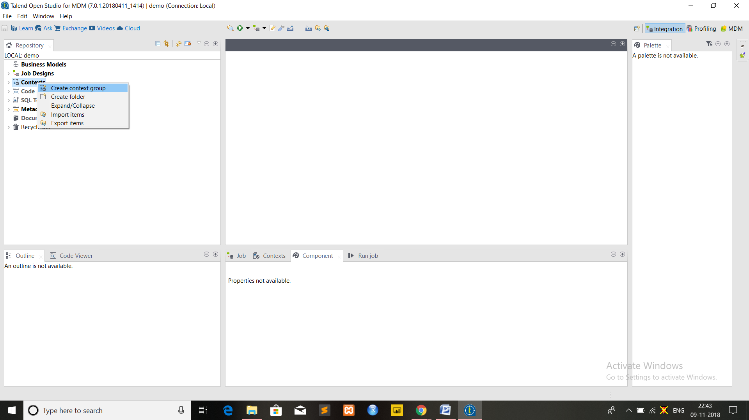

2. Two step window will pop up.

In step-1, fill the different fields like name, purpose and description .For ex ample, here name is taken as TalendContext similarly fill other details and click next.

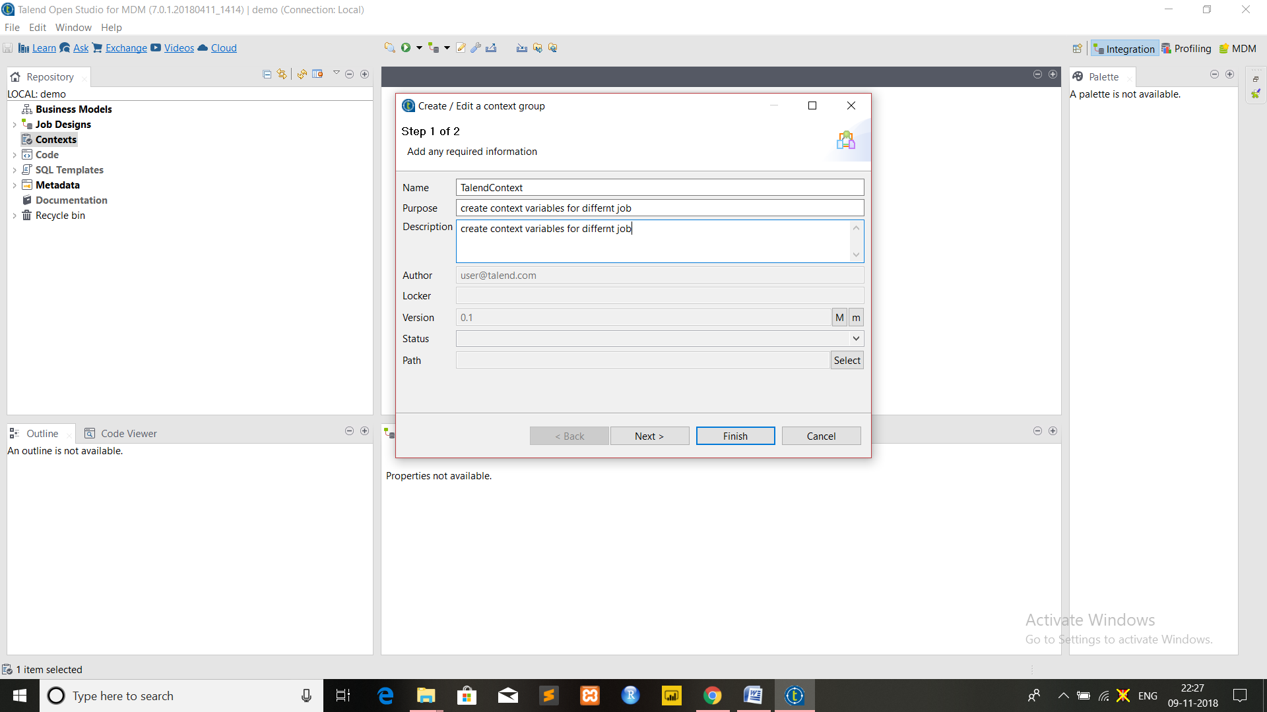

In step-2, this step will allow you to set different context, here context name Default is created by system and is set as default. To create your own context click [+] button(encircled in fig below) on window.

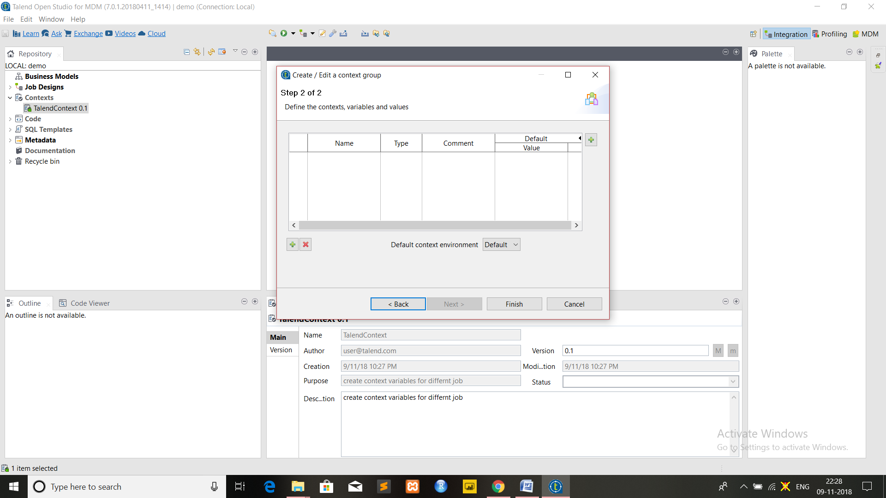

3. The new window pops up.

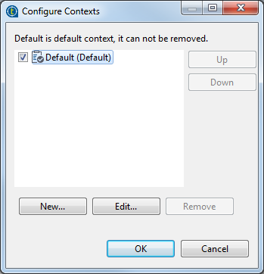

Select Default and Click on edit and rename it as Test and click ok.

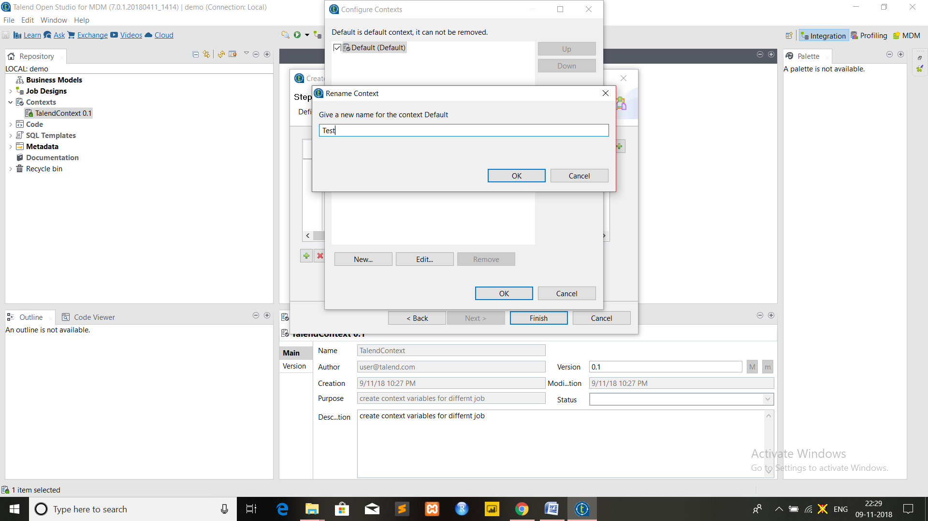

Similarly, create another context production by clicking on New button. Select Test as Default and move it up Using Up button and click Ok to configure the settings.

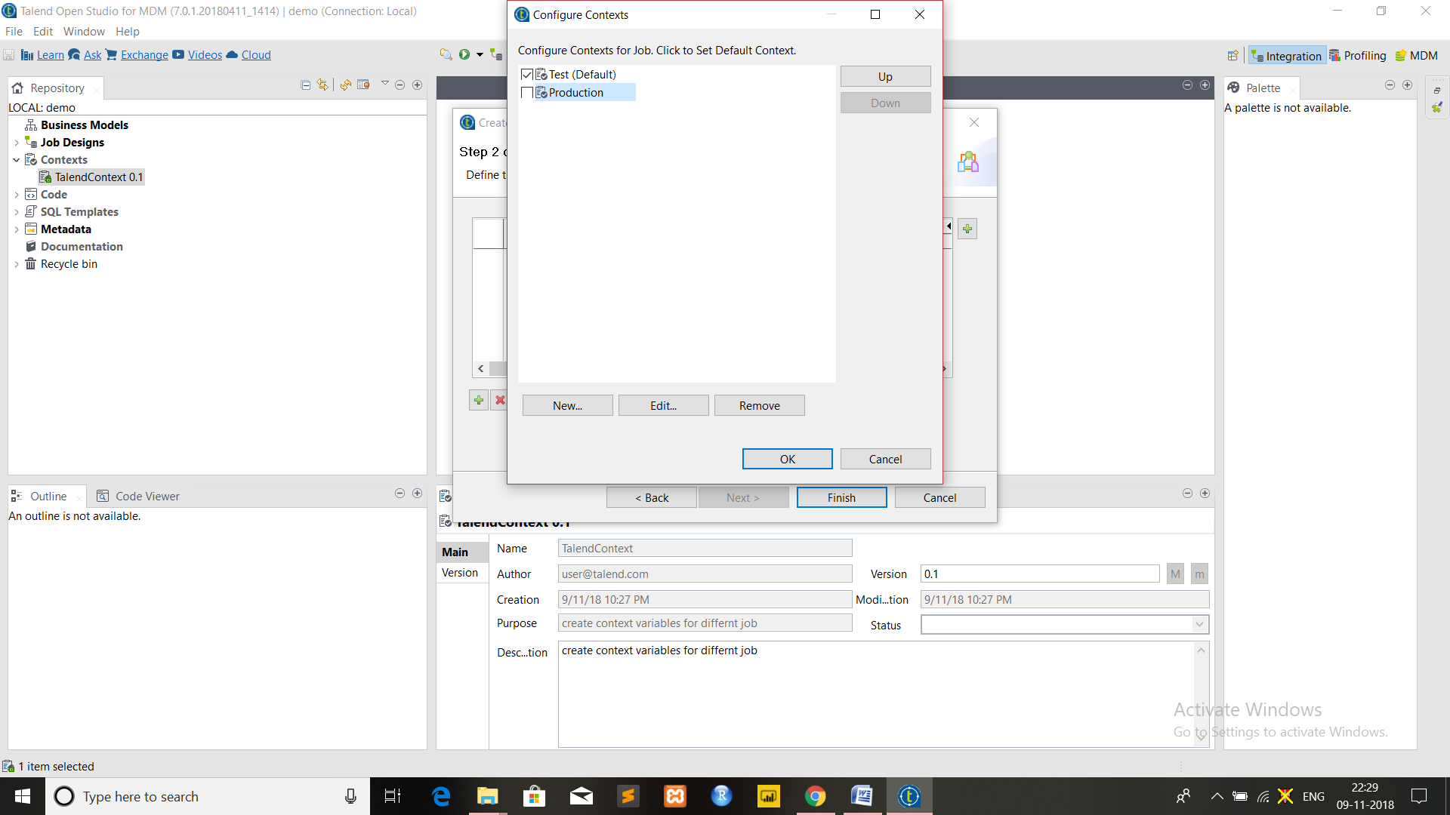

The following window will pop up

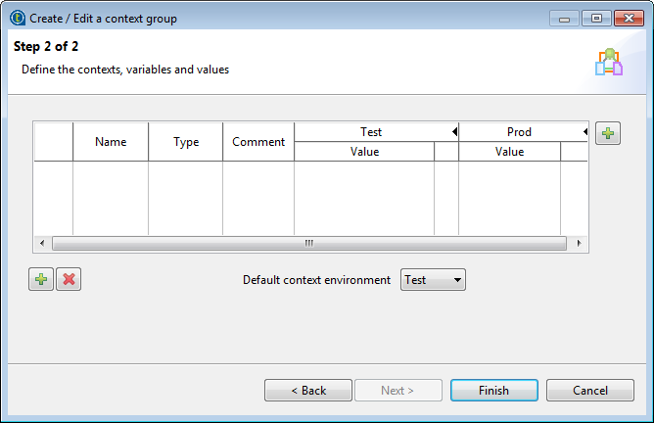

The new context variable will be shown and default variable will be set to Test

Now, click the [+] button to add parameter.

In Name field add name of variable (for ex: host, database etc), in Type select data type of variable and add value for that variable **(Please ensure to add string values in double quote).** Comment can also be added if nedded.

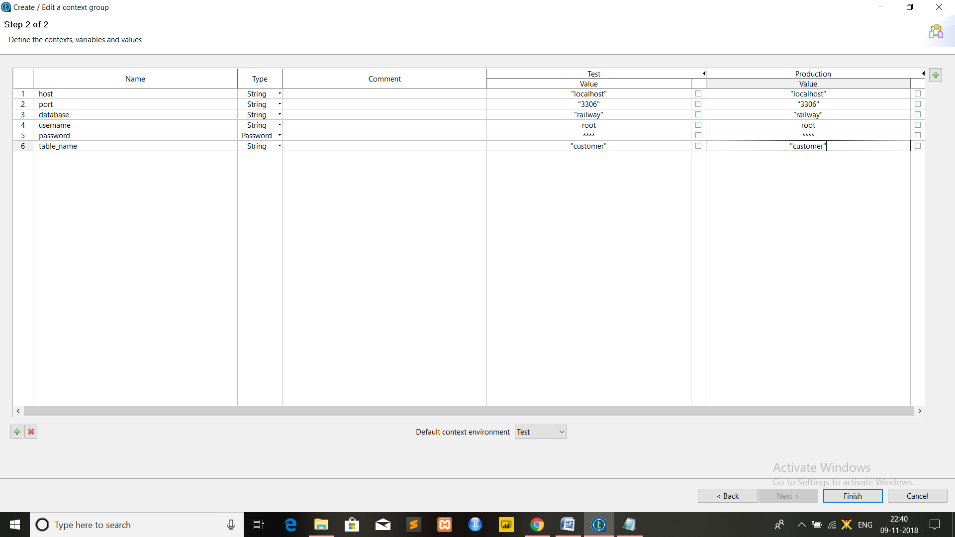

For the above example six name fields are selected as host,database, username, password and table_name, the data type for password is selected as password and for other as string and value for particular is defined. Click Finish to create variable.

The values are taken same as discussed in Prerequisite section.

Here the parameters for Test and Production are taken same as we are not going to for actual production, if interested different values can be taken.

All the variables and their value are displayed on table and ready to use in any Job and the values can also be edited later if needed.

**3. How to apply context variables to a Job**

Steps:

1. Create new job or select job in which you want to apply context variables. ( here new job is created named as UseContextVariable).

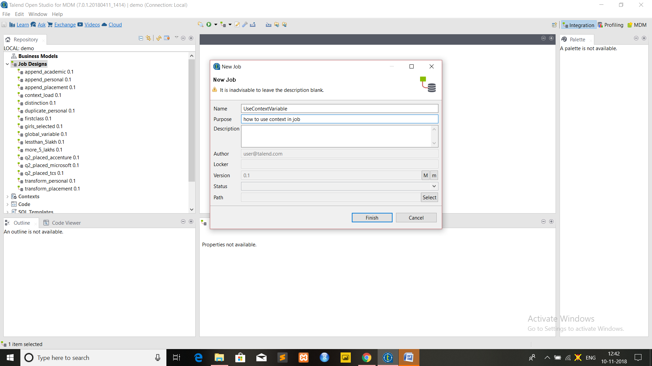

2. Select Context section of your job. It appears as shown in figure below.

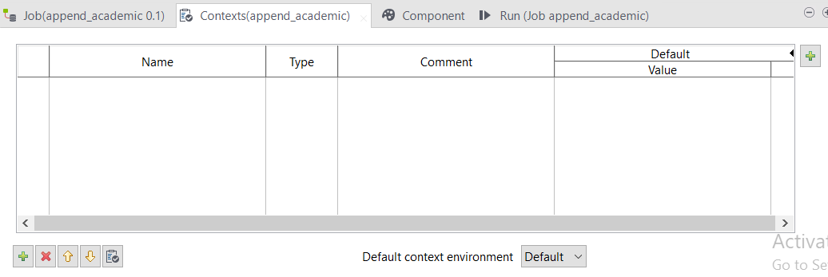

3. Click the icon which is encircled in the figure above. The following window will appear which will have list of all context, select the one you want to use and click ok.

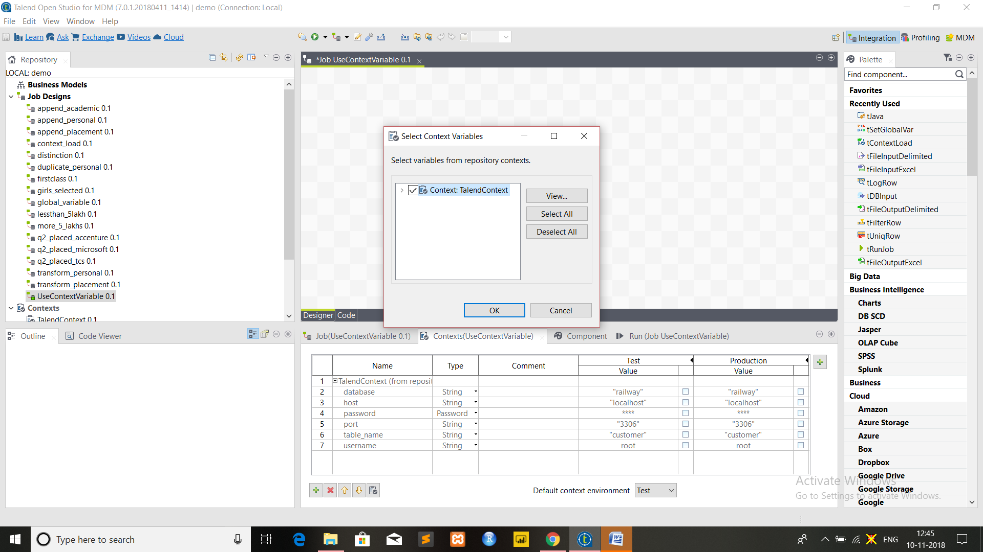

4. Once above step is done Context section will appear as shown in the figure below.

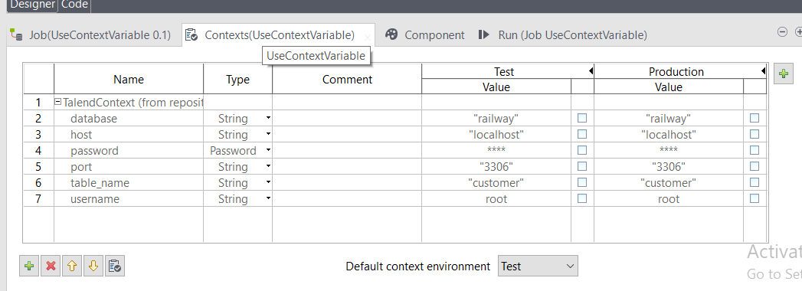

5. Drop tDBInput and tLogRow component from palette to design section and connect them using row->main as shown in figure below.

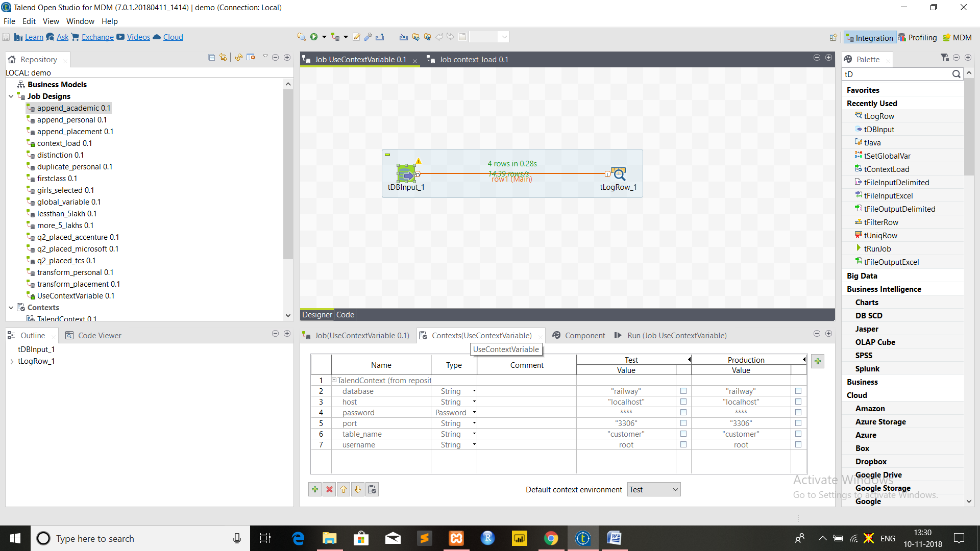

6. Click on tDBInput component and in basic settings select Database as MySQL and new options will arise and fill those option by going on host nd pressing ctrl+space the options for variable will arise and select context.host from it similarly select context.database, context.port, context.usernme, context.password and context.table_name in respective options as shown in figure below.

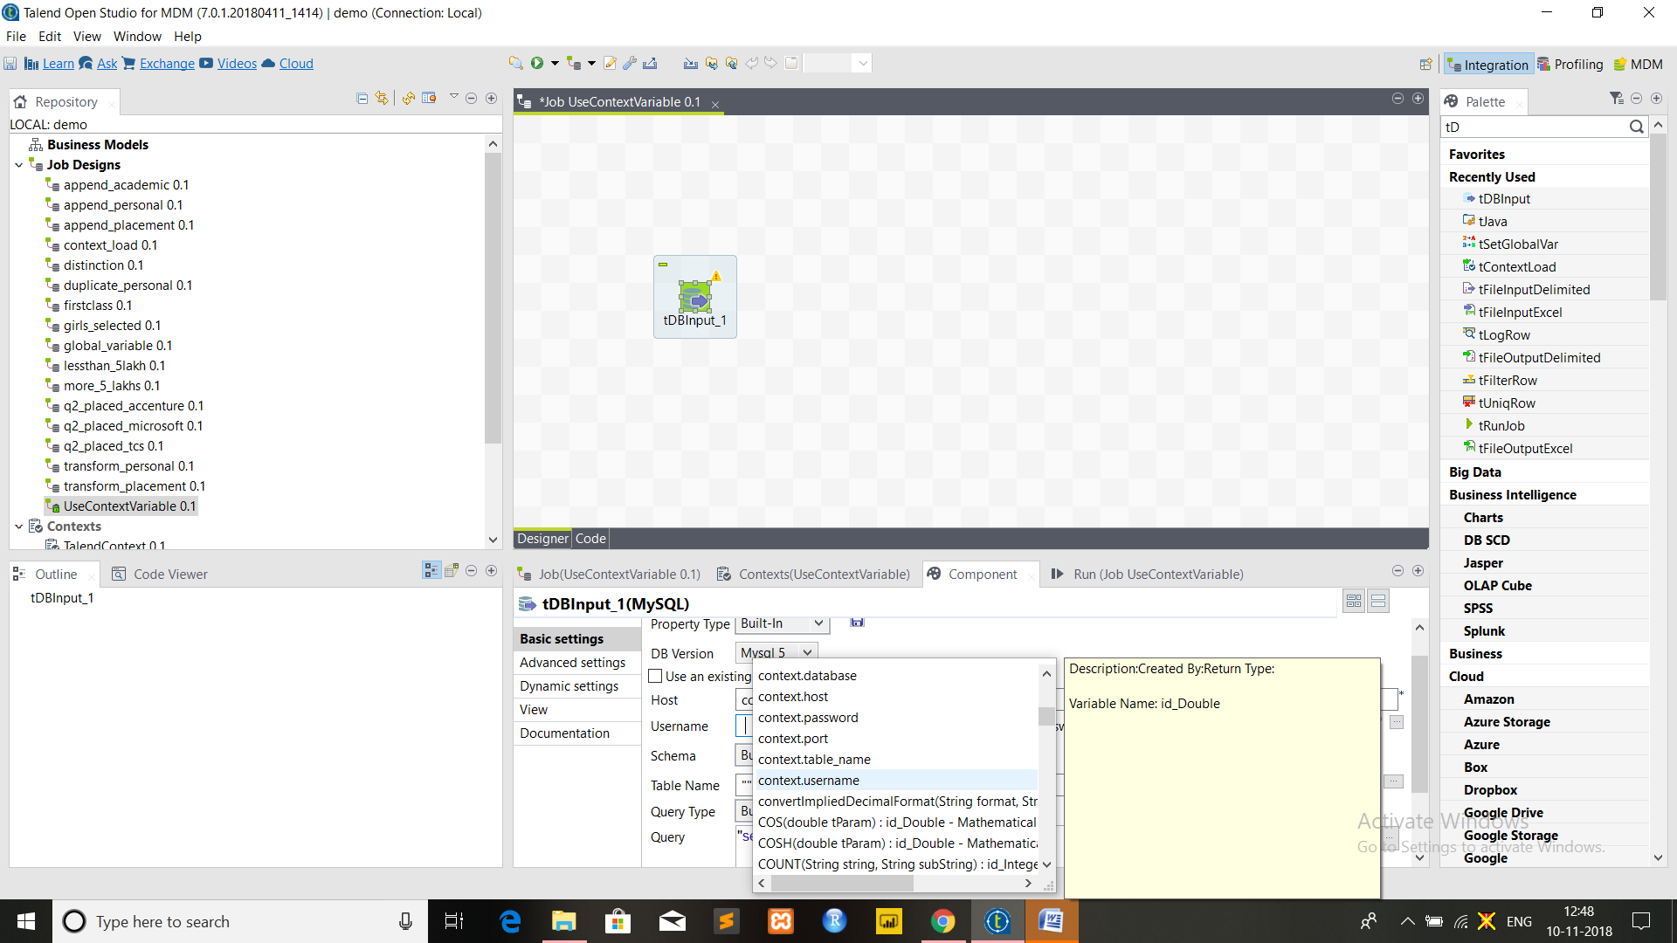

7. In schema and query select Built-In type and click on edit schema option beside schema option. The window shown below will appear as schema for database.

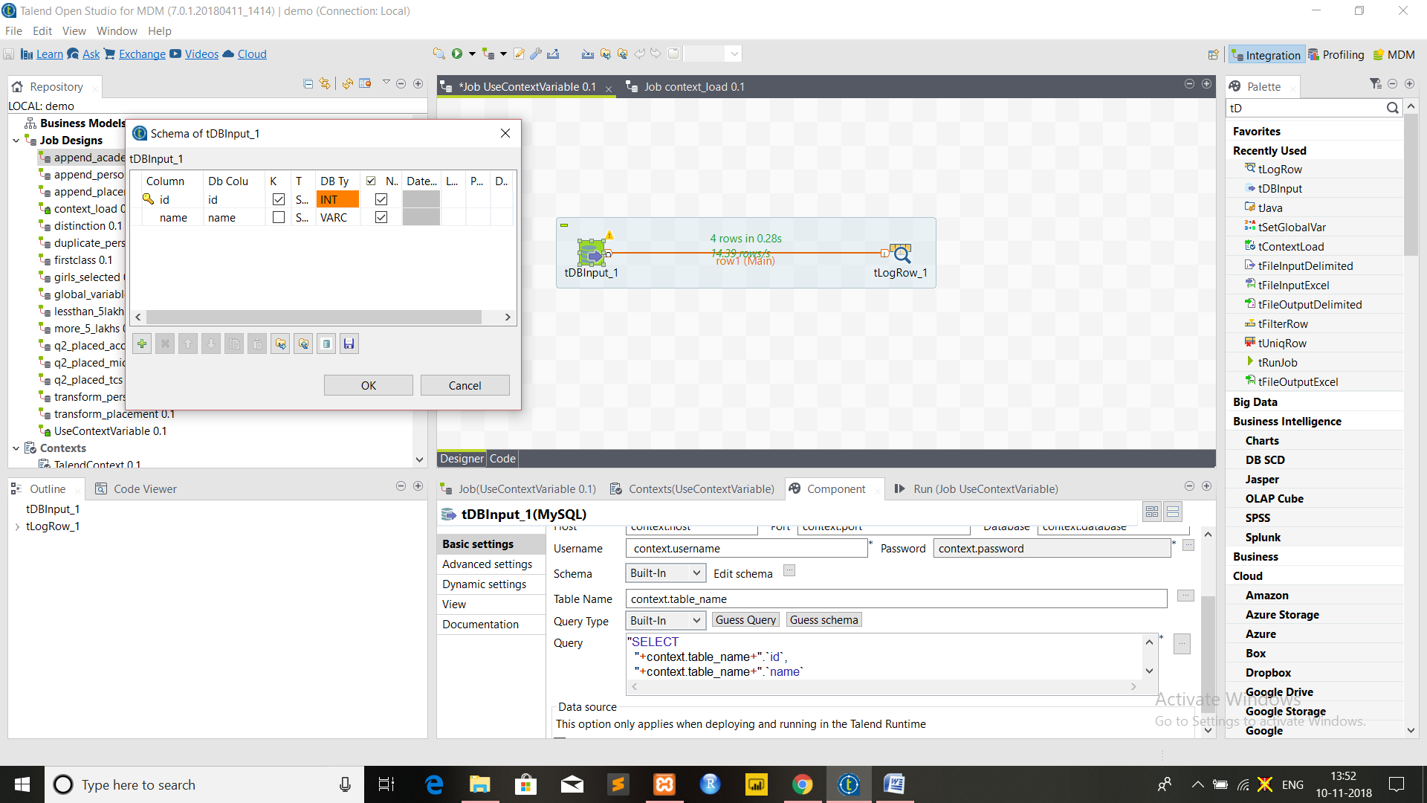

Click [ + ] button from the bottom of window , as many times as the column present in your original tablename you wish to display content of . Fill the column with column name and data type of variable and select primary key.

(Here in this example, id and name is taken as column name because original table which is taken as customer here contains two column id and name)

Click ok to make changes.

Now, beside query option click on guess query button and the query will be generated automatically .Run the job now. Now the contents of your table will be displayed on the console as shown in figure below.

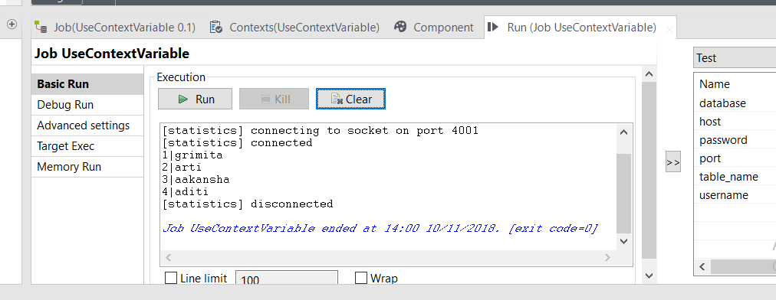

**Warning: Please make sure that the apache and MySQL button of XAMPP is started before running the job.**

**4. Context Values dynamically from a flow or File or Database / Load Context Values from a file**

Steps:

1. Drop tFileInputDelimited and tContextLoad from palette to design workspace. Create first subjob by connecting them using row>main connection

2. Drop tDBInput and tLogRow component from palette to design workspace. Create second subjob by connecting them using row>main connection.

3. Connect two subjobs by using Trigger>On Subjob Ok connection.

Refer the figure below for connections.

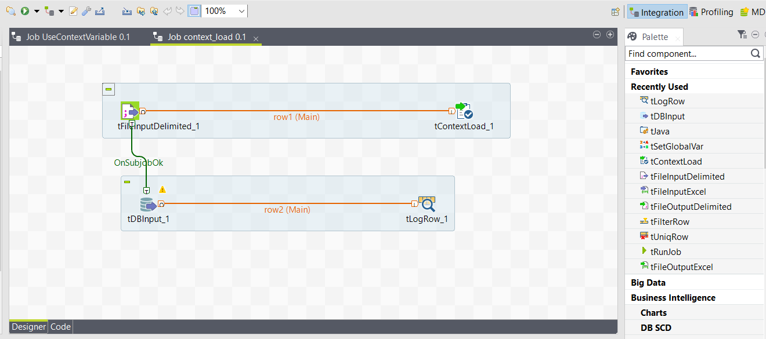

4. Create two text files referring two contexts naming test_connection.txt and prod_connection.txt, both files will contain details of database that are required for test and production purpose. Here details for both production and test are taken same but if needed different database can be referred for test and production purpose.

Insert the following details in both files

host;localhost

port;3306

database;(name of database you are using)

username;root

password;(your password).

5. Select the context section of Job and and add seven rows using [+] button at the bottom of window and fill the following parameters and choose the data type as mentioned in front of each parameter.

host, String type

port, String type

database, String type

username, String type

password, Password type

filename, File type

printOperations, Boolean type

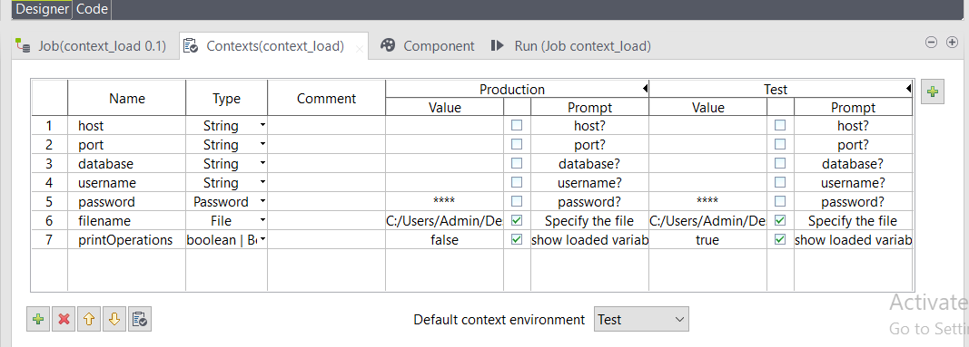

Note that the host, port, database, username and password parameters correspond to the parameter names in the delimited files and are used to set up the desired database connection, the filename parameter is used to define the delimited file to read at Job execution, the printOperationsparameter is used to decide whether to print the context parameters set by the tContextLoad component on the console

6. Click the Contexts tab and click the [+] button at the upper right corner of the panel to open the Configure Contexts window.

7. Select the default context, click the Edit button and rename the context to Test.

8. Click New to add a new context named Production. Then click OK.

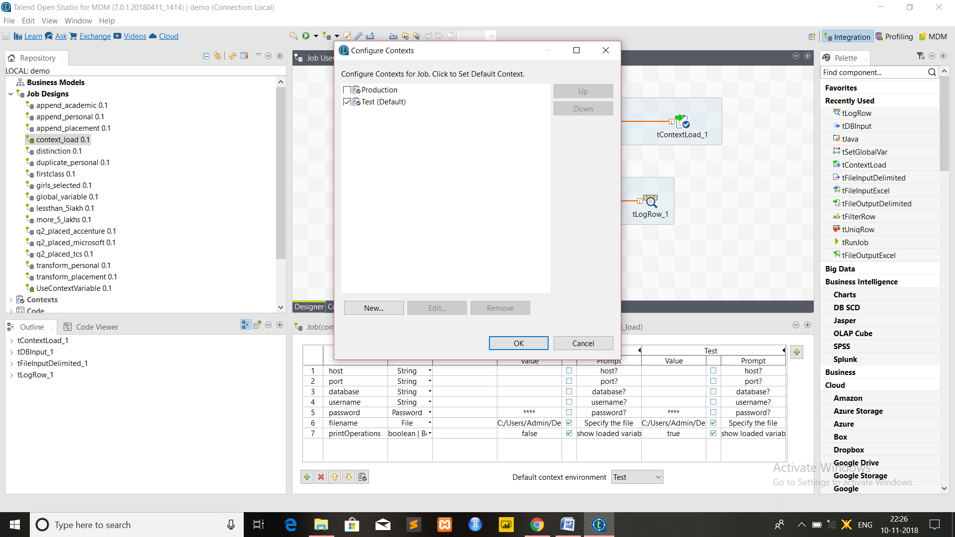

9. In context section select the value for filename by browsing the file path for file test_connection.txt for test context and similarly for production context browse file path of production_connection.txt file and click the check box next to the value and provide promt message that need to displayed while execution.( encircled in figure below)

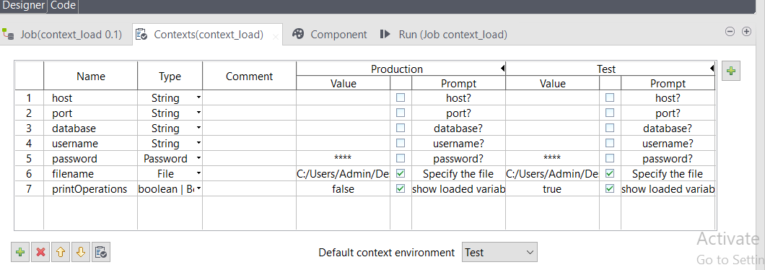

10. In printOperations field set value false for production and true for test context , click on check box and also provide prompt message that need to be displayed while execution.

11. Click on tfileInputDelimited and browse the filename to the path of test_connection.txt file as we are first practicing on test file and same can be done from production file later.Please make sure that “ ; ” is provided as field separated.

12. Click on tContextLoad component and in Dynamic settings by click on [ + ] button define Print operation as context.printOperation (as we have set it true for test context and false for production context).Refer the figure below.

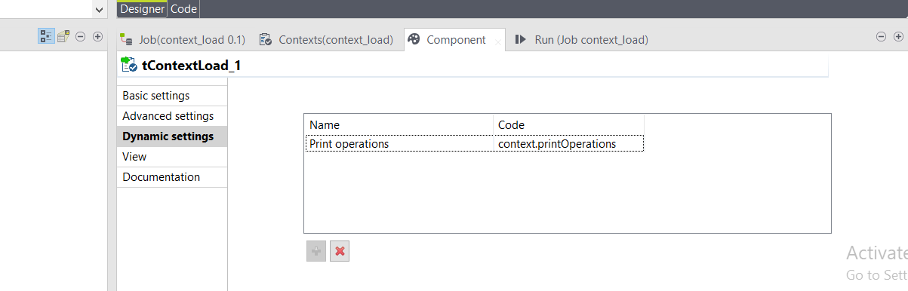

13. Then double-click to open the tMysqlInput component Basic settings view.

14. Fill the Host, Port, Database, Username, and Password fields with the relevant variables context.host, context.port, context.database, context.username,and context.password and fill the Table Name field with the actual database table name to read data from. In schema edit the schema to that of your original table schema similarly as we have done in previous exercise of Applying Context Variable to Job and in query click on Guess Query the query will be generated automatically.

15. Click tLogRow and in basic setting select mode as table for printing

16. Save and run the job.The followingwindow will appear

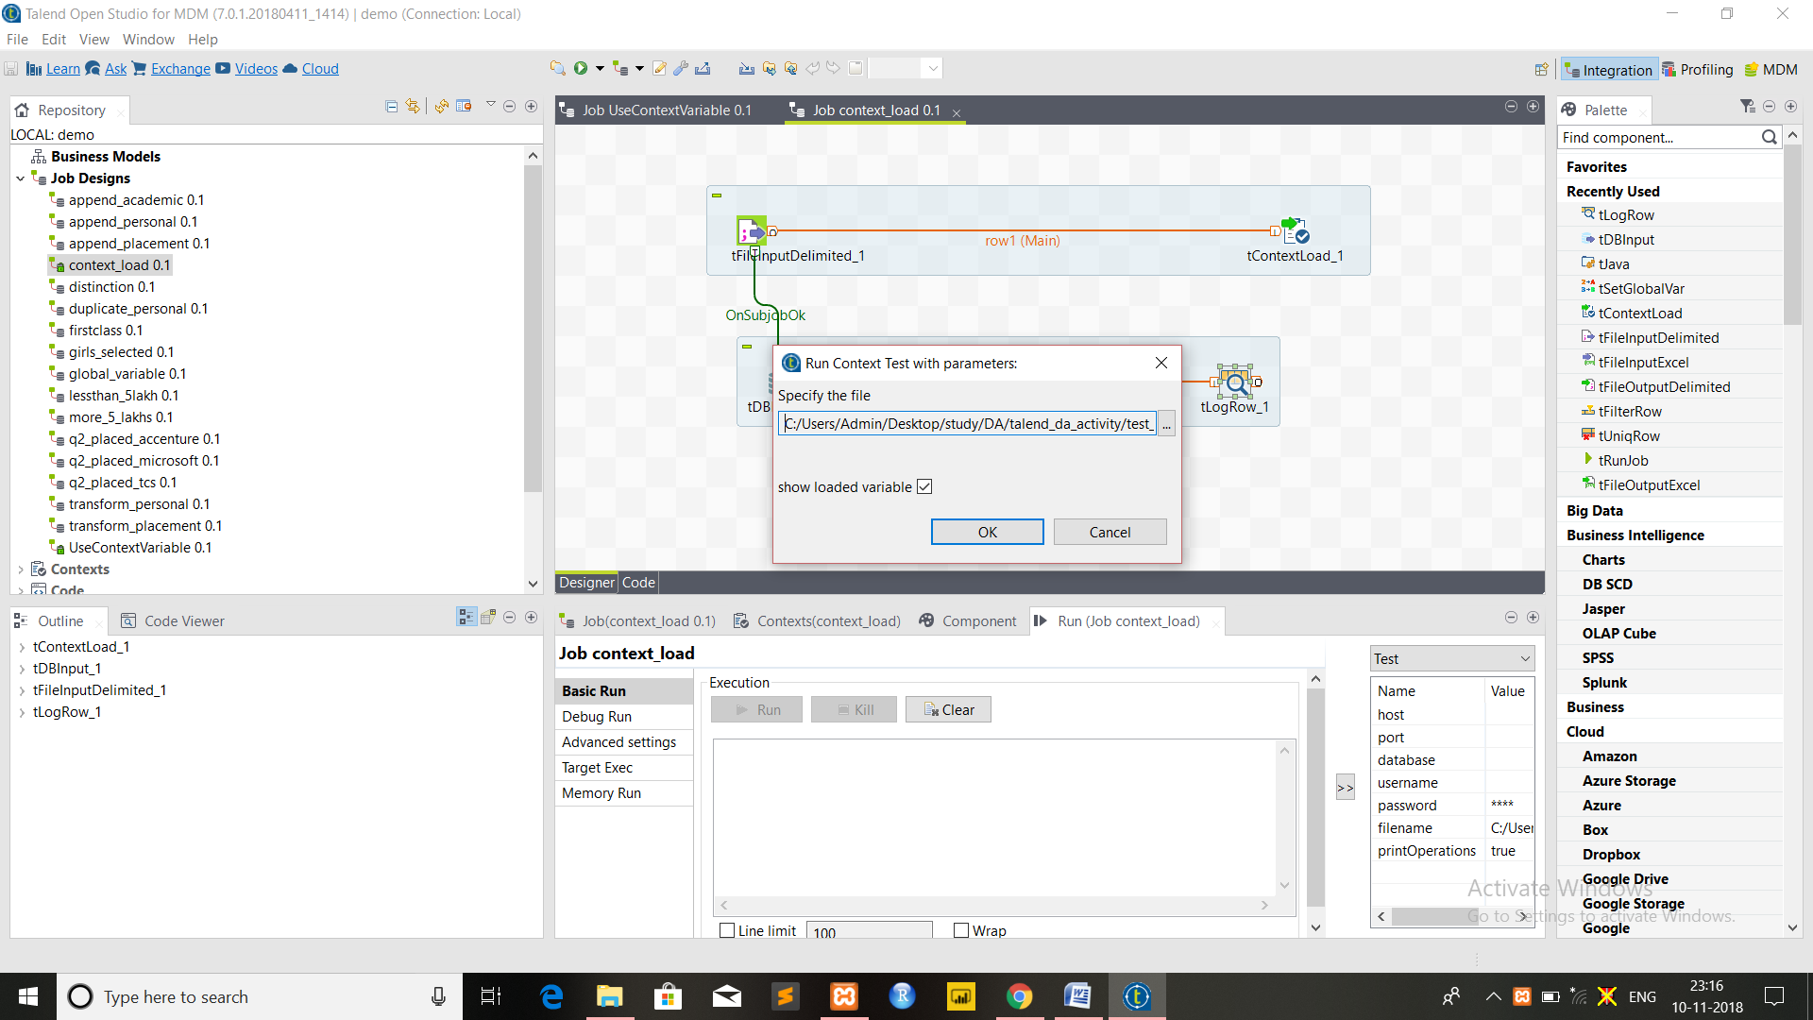

Browse the location of test_connection,txt file and can uncheck the show loaded variable checkbox if value of context variable need not to be printed on console.Click Ok.

17. The table and value of context variable will be printed on console.

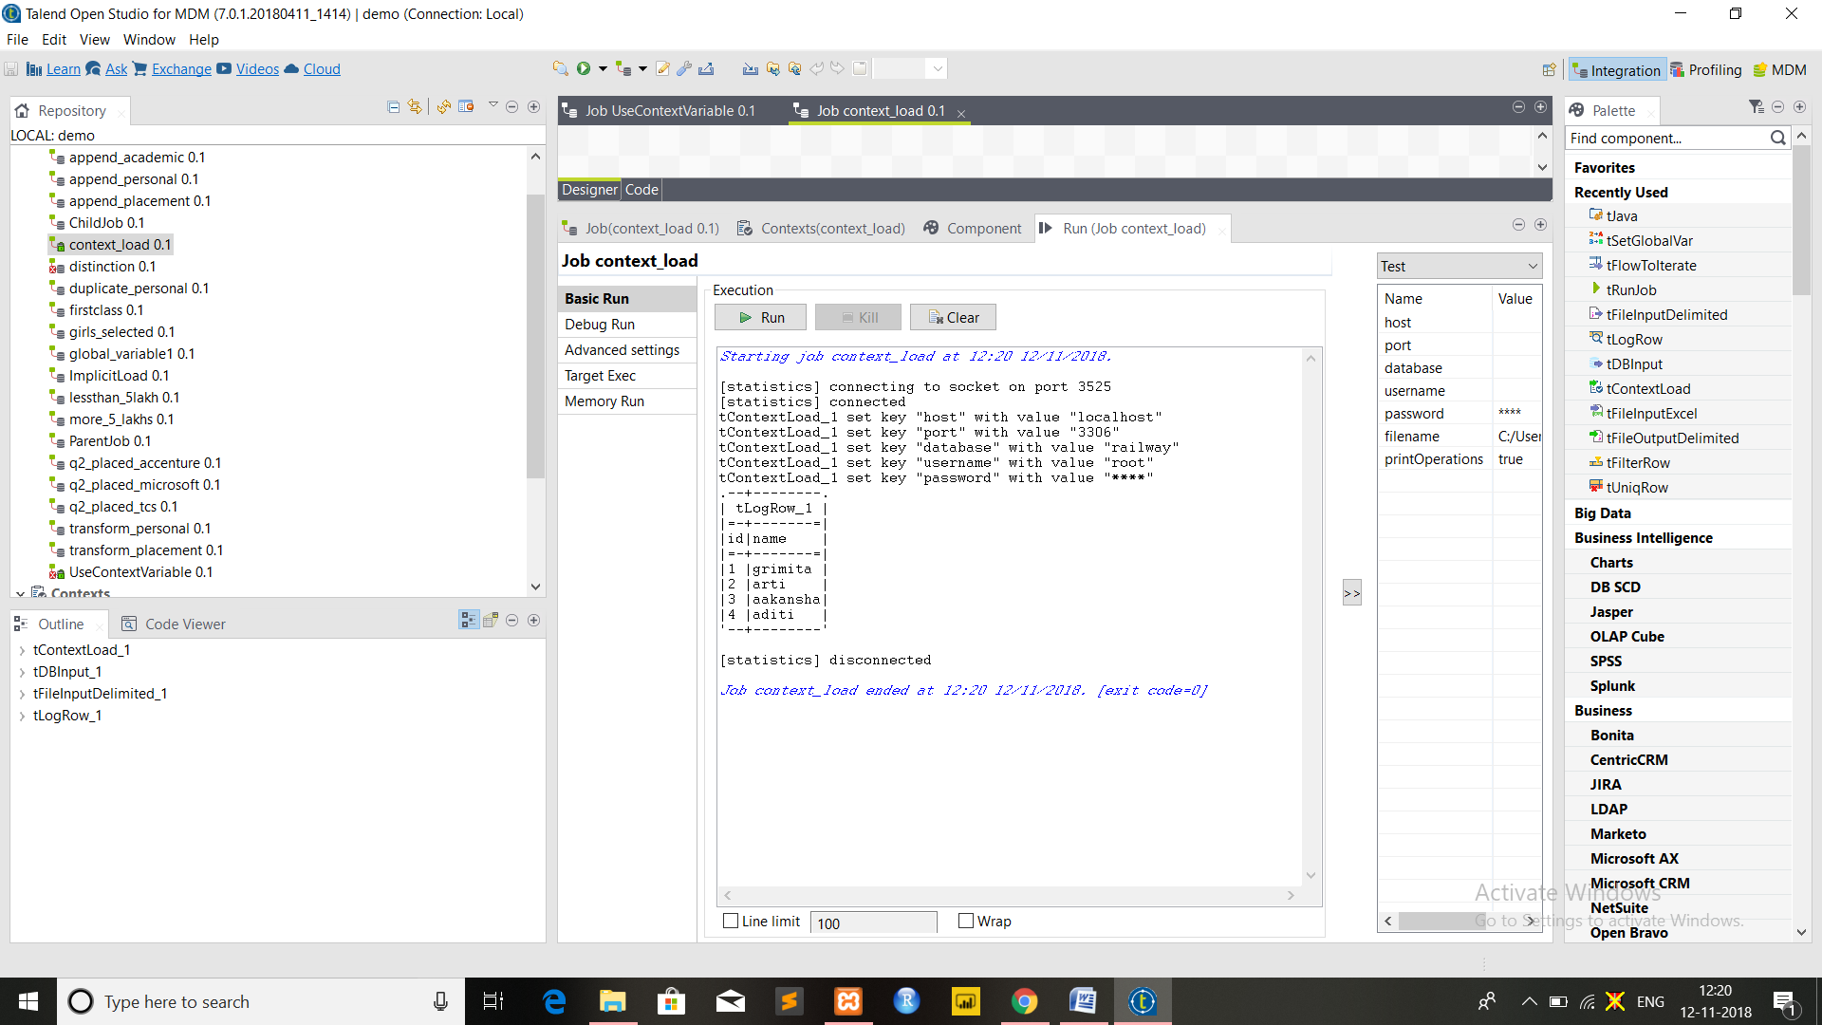

Similar procedure can be followed up for prod_connection.txt file but in this context variable values will not be printed as we have set printOperations as false for production context.

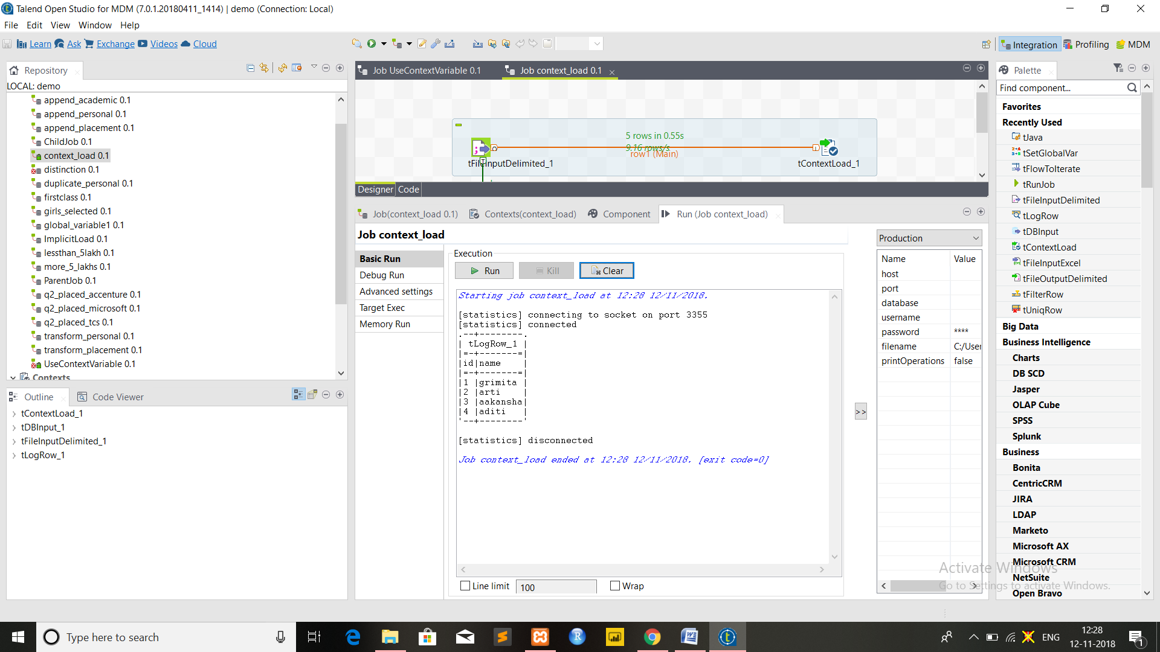

**Warning: Please make sure that the apache and MySQL button of XAMPP is started before running the job**

**5. Using implicit context loading to load contexts / Setup Implicit Context File Location / Load a Context Value from a Properties File**

1. Make new job by giving suitable name.

2. Drop tlogRow component from palette to design area for printing to console.

3. From the job view select the Extra tab.

4. From “Extra” tab select the checkbox ImplicitContextLoad

5. Select one of the either from where you want to load the values i.e. either File or database (here file is selected)

6. Provide the file path to test_connection.txt file and field separator as “ ; “. (same file created in previous exercise).

7. Select print operations and disable warning check box.

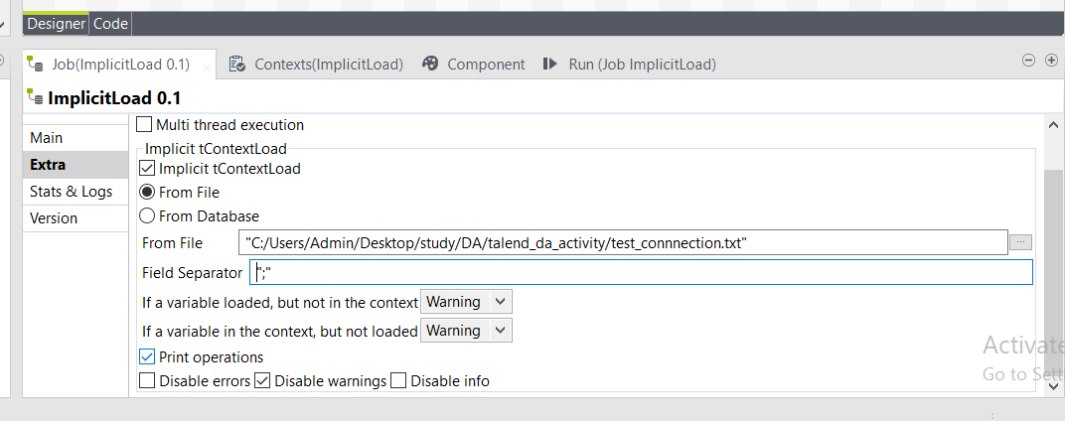

8. Save and Run the job.

9. The values of different variables will be displayed on console.

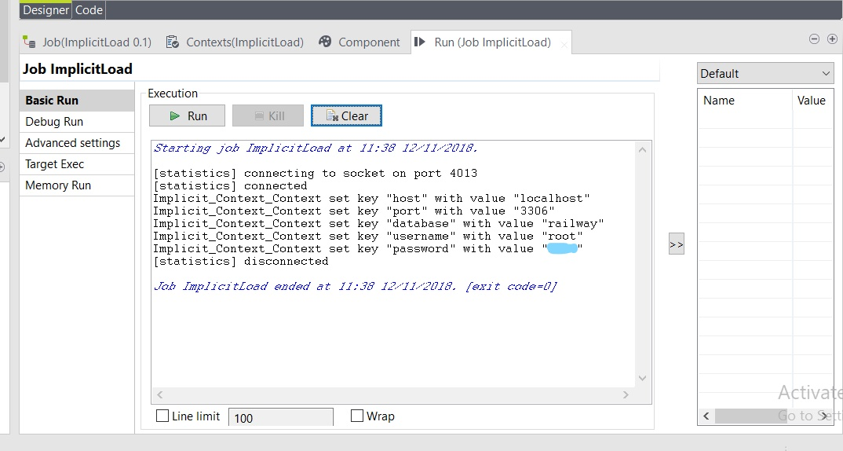

**6. How to Use Studio global variables / How to Create User defined global variables / Using tSetGlobalVar to create Global Variable / Create a Context and Create a globalMap Value Using tJava**

Steps:

1. Drop tSetGlobalVar and tjava component from palette to design area.

2. Connect both component by using Trigger>On Subjob Ok.

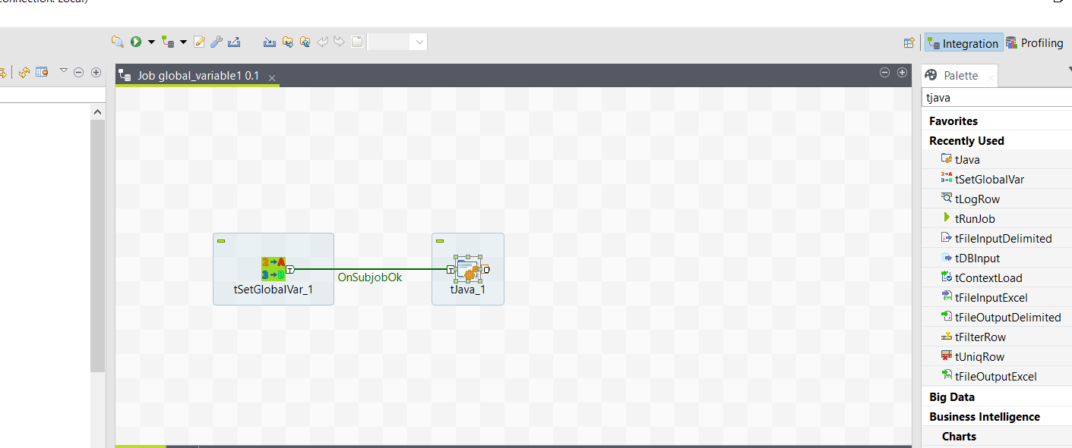

3. Click on tsetglobalVar component and In Basic settings provide key as K1 and Value as 30

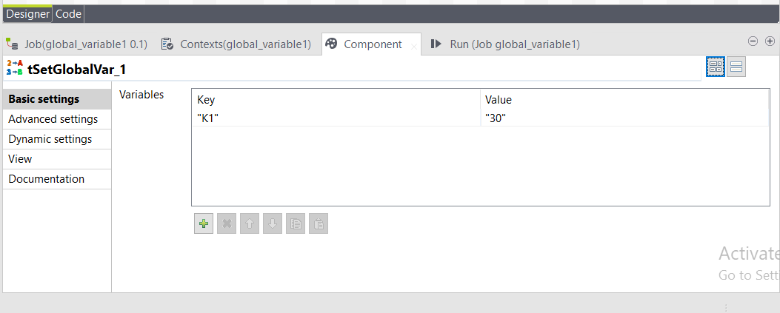

4. Click on tJava component and in code area type :

String foo = "bar";

String K1;

String Result = "The value is:";

Result = Result + globalMap.get("K1");

System.out.println(Result);

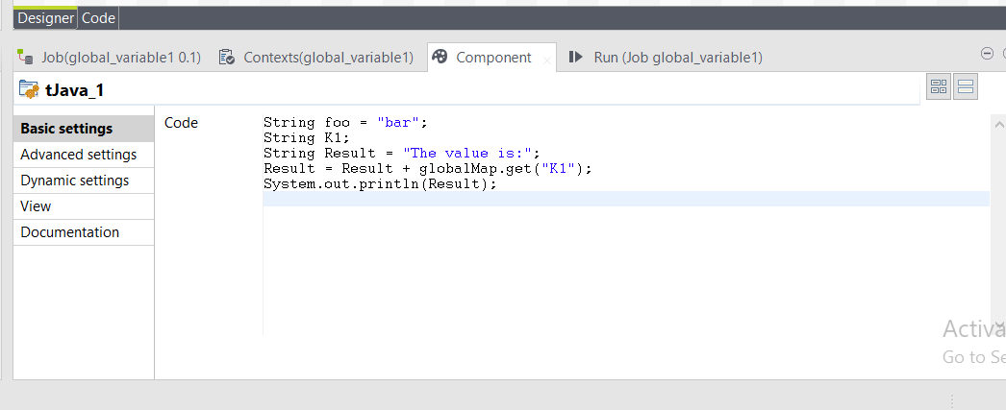

5. Save and Run the job Value of K1 will be printed on console.

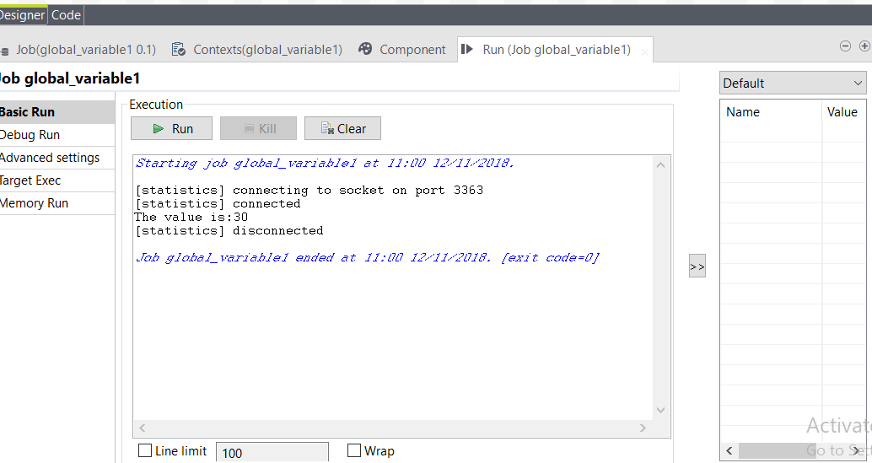

**7. Create a User Defined Global Variable and Pass it as a parameter / Create a User Defined Global Variable and Use it / Use and Print any Global Variable to Console**

In this exercise we pass parameter from parent to child job.

Steps:

1. Create text file named as in.txt with following content

id;name;scope

1;Shong;98

2;Ross;90

3;Tom;55

4;Patrick;99

5;Pedro;90

2. Create a job named as ParentJob and to the design as shown in fig below

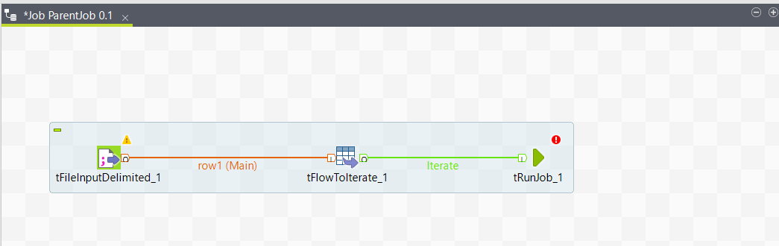

3. Select Basic settings of tFileInputDelimited and browse the file location to the path of in.txt file and set header as 1.

Click on edit schema and add three rows using [+ ] button and give names id,name and scope with data type integer, string and integer respectively.

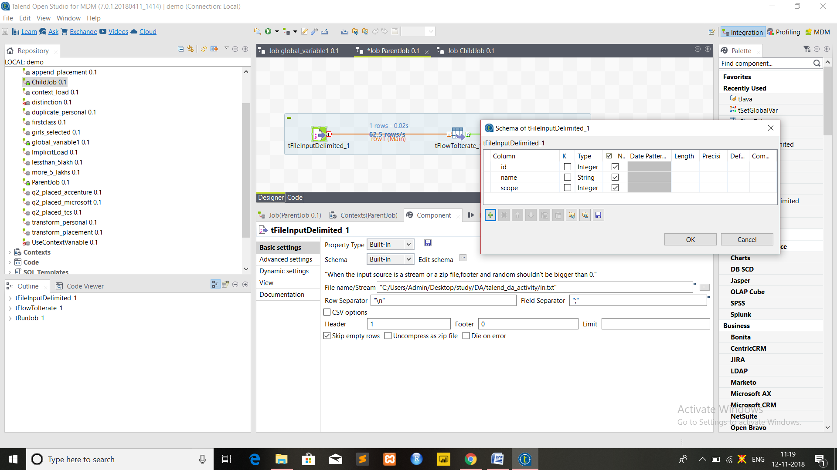

4. Click on tFlowTolterate and in basic settings insure that checkbox “Use the default(key,value) in global variable” is checked.

5. Save the Job

6. Create Child Job and in Context View configure it as follow

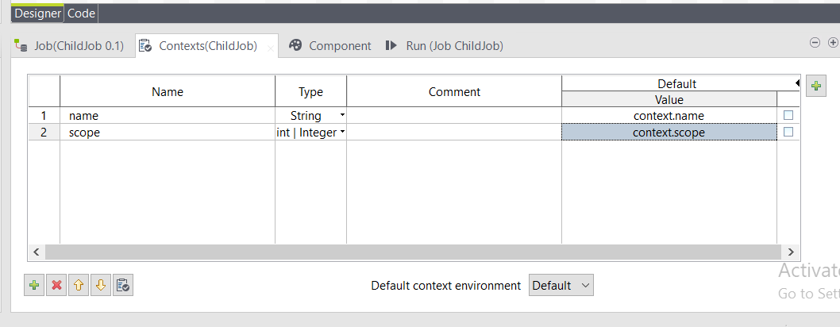

7. Drop tJava palette to designer section and click on tJava and in code section write following code

String message="Hello "+context.name+", you get "+context.scope+" points in this exam!";

System.out.println(message);

8. Save the job.

9.In parentjob click on tRunJob and in basic settings of it select job as the Childjob created.( here ChildJob)

10. In the Basic Settings>**Context Param** field, click the **[+]** button to add the two parameters defined in the **Context** tab as name and scope and define value as shown in figure

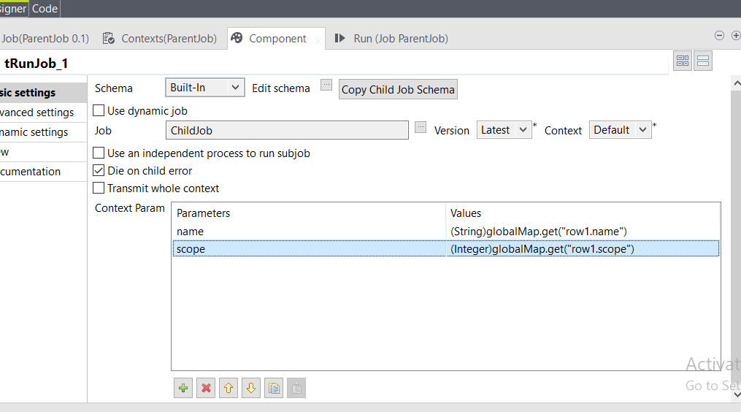

11. Save and Run the Parent Job to get following result on Parent Job console

